**ACADEMIC PATHWAYS: STRATEGIC ON-DRIVE AND OFF-DRIVE PLACEMENT FOR SCHOOL OCCUPATION DIVISIONS AND AFFILIATIONS**

**ASHA D, DINESH S, MURUGAN A, GOKUL PRASATH H**

Head of Department in Information Technology, Loyola Institute of technology, India

E-mail: [ashu.dhanraj5@gmail.com](mailto:ashu.dhanraj5@gmail.com)

Department of Information Technology, Loyola Institute of technology, India

E-mail: dineshkarthick2123@gmail.com

Department of Information Technology, Loyola Institute of technology, India

E-mail: [murugancsdhoni@gmail.com](mailto:murugancsdhoni@gmail.com)

Department of Information Technology, Loyola Institute of technology, India

E-mail: gokul1212h@gmail.com

**Abstract**

***Campus Recruitment System: This is a web-based comprehensive application that seeks to enhance the efficiency and coverage of placement drives undertaken by institutions of learning. As demand for effective employment solutions for students grows, this portal becomes an essential tool for the administrator and coordinator in recruitment. Application. The app allows administrators to govern the recruitment process. Administrators will have the ability to add coordinators into the system. Coordinators are key leaders that also operate on facilitating placements and, once logged in to the system, can give critical information about the upcoming recruitment drives. Essential details such as company names, relevant departments, and specific requirements can easily be fed by coordinators in order to make the students well-informed about available opportunities. In addition, the system allows administrators to upload different requirements of jobs, thereby catering to on-campus and off-campus placements. This opens the whole horizon of employment opportunities to students. The whole approach has streamlined communication from the colleges towards potential employers and better access to job opportunities for students themselves, thus helping create a more efficient recruitment process. The system shall, through this capitalization of technology, bridge the gap between academia and the industries to contribute towards actual employment of the graduates and strengthening the commitment of this institution towards student success amidst the competitive job market.***

***Keywords:***

***Efficiency, Coverage, Streamlined Communication, Enhanced Placement Process, Better Job Access, Industry-Academia Integration, Student Employment, Technological Advancement, Centralized Management, Improved Coordination, Wider Opportunities, Automated Recruitment***

**1. INTRODUCTION**

Today, campus recruitment has become the necessity of the educational institutions keen on having their students attain meaningful job opportunities. Being aware of this aspect, colleges and universities have been engaging themselves in structured placement drives. But conducting the placement drive is not an end; instead, it should be streamlined to be accessible so as to achieve mass participation and involvement among the students. This is where the Campus Recruitment System web application comes in. It is an all-rounded solution for ensuring that the recruitment processes of educational institutions are effectively and promptly managed. The design of the application makes communication of vital information, regarding placement drives going to happen, easy and friendly for the administrators and coordinators.

This system will therefore ensure that accurate information on the opportunities available is communicated to students. Coordinators will thus be able to input vital information, such as company names, departments where recruitment is allowed, and specific job requirements, which will then be included in the application. With application sites available to post both on-campus and off-campus jobs, this further expands the number of opportunities available to the students. Now, through optimum usage of technology, the Campus Recruitment System would make the recruitment process easier and bridge the academic world with the business world, thereby ensuring that students are placed in their jobs successfully.

* 1. **PROBLEM STATEMENT**

The Campus Recruitment System produces the key objective of creating a streamlined and efficient platform that will enhance the campus recruitment process for educational institutions. This will offer improved communication and coordination between the administrators, coordinators, and the students in regards to the placement drives and job opportunities. The application is providing the coordinators with an easy input interface and management of details regarding companies, job requirements, and eligible departments for their recruitment drive in an effective way. It also targets that the students will get information at the right time so as to be prepared for the prospective career accordingly. Furthermore, it bridges the gap between academics and industries since institutions are enabled to advertise both on-campus and off-campus job opportunities. As a result, the students' employment options expand. And finally, having moved in this direction, the goal would aim to create a conducive recruitment atmosphere, from which recruitment adds value not only to employability but also the reputation that is achieved on both the institute and job market levels, indicating proactive career planning and development within the academic community.

**2. LITERATURE SURVEY**

**Title: A Blended Learning Model Based on Smart Learning Environment to Improve College Students' Information Literacy**  
**Author:** Yong Shi, Fei Peng, Fang Sun  
**Year:** 2022

Under the context of the global epidemic, enhancing college students' information literacy has become increasingly crucial. This paper introduces a novel information literacy improvement model specifically designed for college students, leveraging a smart learning environment. The study builds upon existing literature and research, carefully analyzing key elements required to cultivate information literacy in students. These elements are categorized under the CIAP framework, which includes four critical aspects: conceptual level, intelligent level, action level, and process level. The proposed model integrates these components into a blended learning approach to ensure a sustainable improvement in students’ information literacy. The first step involves expanding learning resources through thematic content, followed by the development of an intelligent learning environment. Further, the model emphasizes structured interactive learning activities and introduces an innovative mutual learning process. Learning feedback is assessed promptly, ensuring real-time improvements, and learning evaluation undergoes multiple optimization strategies to enhance its effectiveness. To validate the effectiveness of this approach, targeted experiments were conducted among engineering technology students in a Chinese university. A comparative analysis between an experimental group and a control group revealed a statistically significant difference in post-test results, proving that the blended learning model based on a smart learning environment is effective in enhancing students' information literacy. The study further explores the spiral development of information literacy within a smart learning environment, offering insights into its long-term sustainability. The findings highlight the importance of integrating digital learning models into education to better equip students with essential information literacy skills.

**Title: Evidence for Large Long-Term Memory Capacities in Baboons and Pigeons and Its Implications for Learning and the Evolution of Cognition**  
**Author:** Joël Fagot, Robert G. Cook  
**Year:** 2010

Extensive research has demonstrated that both birds and primates exhibit complex behavioral and cognitive abilities; however, the underlying mechanisms responsible for these capabilities remain largely unexplored. One prevailing hypothesis suggests that these abilities are facilitated by highly efficient long-term memory, which enables animals to store and recall specific external events while associating appropriate responses to them. Prior studies did not extensively challenge the memory capacities of animals, leading to the necessity for this comparative research. This study systematically examined and compared the long-term memory capacity in baboons and pigeons using equivalent experimental procedures. The results indicated significant, though distinct, memory capabilities in both species. Pigeons were found to memorize between 800 and 1,200 picture–response associations before reaching their performance threshold. In contrast, baboons demonstrated a significantly higher capacity, memorizing between 3,500 and 5,000 associations, with no clear upper limit even after three years of continuous testing. Despite these differences in memory storage capabilities, the methods of memory retention and processing appeared to be similar between the two species. These findings suggest that both baboons and pigeons possess the necessary cognitive resources to utilize memory-based learning strategies in experimental conditions. Additionally, the results support the theory that cognitive and behavioral evolution has been largely influenced by the progressive expansion of long-term memory capacities within the brain. This study provides a deeper understanding of memory-based learning and offers critical insights into the evolutionary development of cognitive functions in animals.

**3. PROPOSED METHOD**

The proposed system enhances the placement process by providing a centralized web-based platform accessible to students from the college and external institutions. Each student can log in using a unique username and password to access detailed placement information. Unlike traditional placement management methods, this system allows students to upload external placement opportunities, making them visible to all users. The system is hosted on AWS Elastic Beanstalk, ensuring automated deployment, scalability, and high availability with features like load balancing and auto-scaling, which optimize performance during peak usage. SQL operations efficiently manage structured placement data, while the AES Algorithm secures sensitive user information. Additionally, AWS RDS stores and handles student and company records with automated backups and failover protection. The HyFlex model is integrated to support a hybrid learning and recruitment approach, allowing students to access placement-related training and interviews online and offline. The platform streamlines communication between students, placement officers, and recruiters, offering categorized CV storage, company access to student information, and a historical placement database. The user-friendly interface enables students to track their placement progress, update profiles, and stay informed about opportunities.

**4. MODULES**

**4.1. STUDENT**

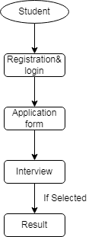

Fig 1. Student Module

**4.2. PLACEMENT DEPARTMENT**

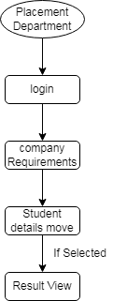

Fig 2. College Module

**4.3. COMPANY**

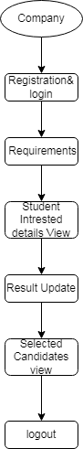

Fig 3. Company Module

**5. REQUIREMENTS**

**5.1 HARDWARE REQUIREMENTS:**

The hardware requirements may serve as the basis for a contract for the implementation of the system and should therefore be a complete and consistent specification of the whole system. They are used by software engineers as the starting point for the system design. It shows what the system does and not how it should be implemented.

PROCESSOR : PENTIUM IV 2.6 GHz, Intel Core 2 Duo.

RAM : 4GB DD RAM

MONITOR : 15” COLOR

HARD DISK : 40 GB

**5.2 SOFTWARE REQUIREMENTS:**

The software requirements document is the specification of the system. It should include both a definition and a specification of requirements. It is a set of what the system should do rather than how it should do it. The software requirements provide a basis for creating the software requirements specification. It is useful in estimating cost, planning team activities, performing tasks and tracking the team’s and tracking the team’s progress throughout the development activity.

Front End : J2EE(JSP,SERVLETS)JAVASCRIPT

Back End : MY SQL 5.5

Operating System : Windows 07

IDE : Eclipse

**5.3. ALGORITHMS USED**

The **AES algorithm** (also known as the **Rijndael algorithm**) is a symmetrical block cipher algorithm that takes plain text in blocks of 128 bits and converts them to cipher text using keys of 128, 192, and 256 bits. Since the AES algorithm is considered secure, it is in the worldwide standard.

How does AES work?

The AES algorithm uses a substitution-permutation, or SP network, with multiple rounds to produce cipher text. The number of rounds depends on the key size being used. A 128-bit key size dictates ten rounds, a 192-bit key size dictates 12 rounds, and a 256-bit key size has 14 rounds. Each of these rounds requires a round key, but since only one key is inputted into the algorithm, this key needs to be expanded to get keys for each round, including round 0.

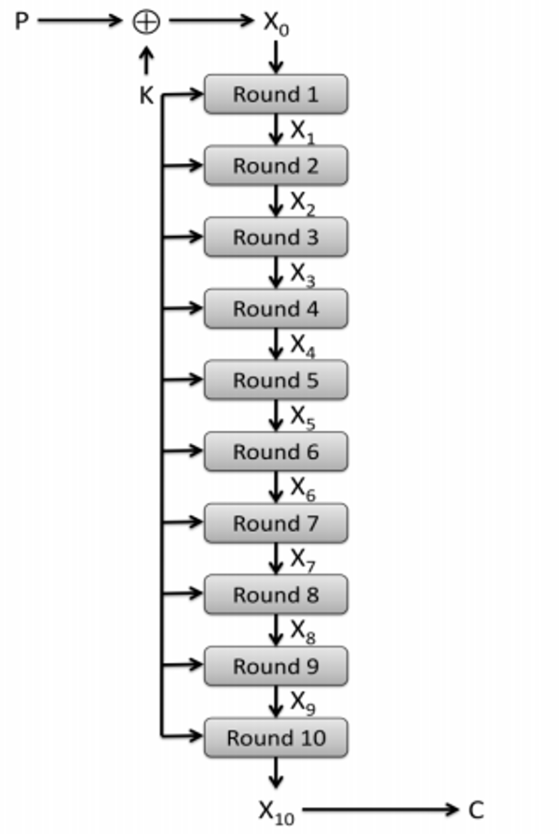

Fig 4. Rijndael algorithm

**6. FEASIBILITY STUDY**

Feasibility studies aim to objectively and rationally uncover the strengths and weaknesses of the existing business or proposed venture, opportunities and threats as presented by the environment, the resources required to carry through, and ultimately the prospects for success.

In its simplest term, the two criteria to judge feasibility are cost required and value to be attained. As such, a well-designed feasibility study should provide a historical background of the business or project, description of the product or service, accounting statements, details of the operations and management, marketing research and policies, financial data, legal requirements and tax obligations. Generally, feasibility studies precede technical development and project implementation.

They are 3 types of Feasibility

• Economical feasibility

• Technical feasibility

• Operational feasibility

**6.1. ECONOMICAL FEASIBILITY**

The economic feasibility of the Campus Recruitment System is evaluated by analyzing the costs associated with its development, deployment, and maintenance against the benefits it provides. The system is designed to be cost-effective by utilizing web-based technology that minimizes infrastructure expenses. Since it is developed using SQL operations for data management and the AES Algorithm for security, the cost of software and security measures remains within a manageable range. Additionally, the system reduces administrative overhead by digitizing placement records, automating updates, and streamlining communication between students, coordinators, and recruiters. The scalability of the system ensures that as student enrollment and company participation grow, the additional costs remain minimal compared to the manual placement processes. By providing a centralized, paperless approach, the system significantly lowers costs related to physical storage, document handling, and labor efforts. The return on investment (ROI) is high since it enhances placement success rates, reduces operational delays, and provides students with real-time access to job opportunities, making it a financially viable solution.

**6.2. TECHNICAL FEASIBILITY**

The technical feasibility study ensures that the Campus Recruitment System meets all technical requirements without exceeding the available resources. The system is developed using SQL operations for efficient database handling, allowing quick retrieval and storage of student and placement records. The AES Algorithm ensures secure authentication and data protection, safeguarding sensitive user information. The web-based nature of the system ensures cross-platform accessibility, allowing students, coordinators, and recruiters to access it from desktops, laptops, and mobile devices without requiring additional hardware. The HyFlex method is integrated to enhance hybrid access, ensuring that both online and offline placements are managed effectively. The system is built with a user-friendly interface, reducing the need for extensive training and support. Since the technologies used are widely available and supported, there are no significant technical constraints in implementing the system, making it feasible from a technical standpoint.

**6.3. OPERATIONAL FEASIBILITY**

Operational feasibility assesses the user acceptance and effectiveness of the system in real-world usage. The Campus Recruitment System is designed with an intuitive interface, ensuring that students, coordinators, and recruiters can easily navigate and utilize its features without requiring extensive training. Students can log in, upload their resumes, track placement opportunities, and receive notifications about new job openings. Coordinators can efficiently manage placement schedules, update job postings, and communicate with students. Recruiters can access categorized student CVs, filter candidates based on skills and academic performance, and schedule interviews seamlessly. The system also allows students to view past placement records and external job opportunities uploaded by peers, ensuring a comprehensive and transparent placement process. Since the system eliminates paperwork and enhances accessibility, users are more likely to accept it as a necessary and valuable tool rather than a burden. Training modules and step-by-step guides will be provided to ensure smooth adoption, increasing overall operational efficiency.

By addressing economic, technical, and operational feasibility, the Campus Recruitment System proves to be a cost-effective, technically viable, and user-friendly solution that enhances student employability while optimizing institutional placement management.

**7. CONCLUSION**

Campus Recruitment System is the biggest step forward in the mode of management and execution of placement drives by educational institutions. The system presents a single-portal platform that ensures proper communication and coordination among administrators, coordinators, and students in a most effective manner to not just automate the recruitment process but also to better engage and prepare the students for the markets. With the ability to manage both on-campus and off-campus opportunities, the application widens the students' horizons to find available jobs in all possible settings. Further, after equipping the integration of data analytics, the institutions will be able to assess their recruitment strategy very effectively; hence they can continue improving and adapting other requirements of the industries. Finally, the Campus Recruitment System plays a vital role as a bridge between academic and professional environments, thereby contributing to the successful transition of students into an increasingly competitive job market and reinforcing the commitment of educational institutions to fostering student success and employability.

**REFERENCE**

[1]. Santosh Kumar H,” Online Training and Placement Management system”, International Journal of Engineering Research Technology (IJERT), ICACT - 2016 Conference Proceedings.

[2]. Mythili M, Aishwarya R, Shenbagam P, Sandhiya C,” E Placement Management”, International Jour- nal of Pure and Applied Mathematics(IJPAM), Volume 119 No. 10 2018,1823-1834.

[3]. Anjali v, Jeyalakshmi PR, Anbubala R,Sri Mathura devi, Ranjini.V, ”Web Based Placement Management System”, International Journal of Computer Science and Information Technologies(IJCSIT), Vol. 7 (2) , 2016, 760-763.

[4]. Rajnesh Tripathi, Raghvendra Singh, Jaweria Usmani, ”Campus Recruitment and Placement Sys- tem”, International Conference on Recent Innovations in Science and Engineering(Icrise-18), April, 2018.

[5] Tejashri Gosavi, Shraddha Gaikwad, “Android Based Training and Placement Automation”, Department of Computer Engineering, JSPM’s ICOER , Wagholi , Pune , India.

[6] Vidhate, Deepak, A; Kulkarni, Parag (2014):“Improvement In Association Rule Mining By Multilevel Relationship algorithm” in International Journal of Research in Advent Technology, 2(1), pp.366-373

[7] Alfiya Banu, Dr. Manju Bargavi S. K, "A Research on Placement Management System," International Journal of Research in Applied Science and Engineering Technology (IJRASET), Volume 10, Issue 5, May 2022.

[8] Nitin Pathak, Pushpraj Gendre, Sanskar Jain, Bhaskar Soni, Prof. Archana Senapati, "Placement-Cell Management System," International Research Journal of Modernization in Engineering, Technology and Science (IRJMETS), Volume 6, Issue 5, May 2024.

[9] Anjali V, Jeyalakshmi PR, Anbubala R, Sri Mathura Devi G, Ranjini V, "Web Based Placement Management System," International Journal of Computer Science and Information Technologies (IJCSIT), Vol. 7, No. 2, 2016, pp. 760-763.

[10] Kamal Acharya, "Training and Placement Cell Management System," ResearchGate, November 2024.

[11] Nitin Pathak, Pushpraj Gendre, Sanskar Jain, Bhaskar Soni, "Placement-Cell Management System," International Research Journal of Modernization in Engineering, Technology and Science (IRJMETS), Volume 6, Issue 5, May 2024.

[12] "Placement Management System," ResearchGate, March 2023.